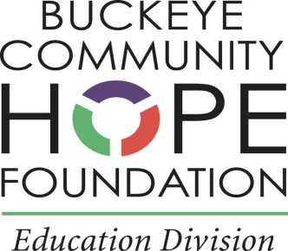

November 26, 2019

Dear Parents and Students:

Your school is sponsored by Buckeye Community Hope Foundation.

As the sponsor we are required by Ohio law to report on an annual basis the results of the evaluation of your school’s performance for the most recent school year and provide (access to) a copy of the Annual Report to parents of students enrolled in the community school.

The Annual Report for your school can be found on the Buckeye Community Hope Foundation website at:

<http://buckeyehope.org/community-schools/>

***BCHF Annual Report***

and on your school’s website:

<https://epvpwoodlandhills.org/>

Statutory and Code Reference: Ohio Revised Code 3314.03(D)(3), ORC 3314.03(A)(11)(g) and Ohio Administrative Code 3301-102-05.